SMASH MSCA Fellowships

PROJECT TITLE:
Please write here your project title

PROJECT ACRONYM:
Please write here your project acronym

In drafting the proposal, applicants must follow the structure outlined below.
This page and all similar instructions in italics should be deleted.
FRONT PAGE (1 page)

START PAGE COUNT (MAX 10 PAGES SECTIONS 1-3)
1. EXCELLENCE
2. IMPLEMENTATION AND FEASIBILITY
3. DISSEMINATION AND IMPACT
STOP PAGE COUNT (MAX 10 PAGES SECTIONS 1-3)
ETHICS SELF-ASSESSMENT
GANTT CHART
The Front Page, Ethics self-assessment and Gantt Chart are not part of the page count.
The following template (from page 4 of this document) can be directly filled if you use Microsoft Word.
If you want to use an alternative solution of text editor, you may strictly use the following parameters for your template:

Your proposal must respect the following standards:
- A4 page size
- Use the reference font for the body text of H2020 proposals: Times New Roman (Windows platforms), Times/Times New Roman (Apple platforms) or Nimbus Roman No. 9 L (Linux distributions).
- The minimum font size allowed is 11 points. Standard character spacing and a minimum of single line spacing is to be used. Text elements other than the body text, such as headers, footnotes, captions, formulae, may deviate, but must be legible; however, these elements should not be used as a mechanism to circumvent the rules. For example, text within a table or graphical element should be kept to a minimum.
- Single line spacing
- All margins (top, bottom, left, right) should be 2 cm minimum
- All pages should be numbered in a single series on the footer of the page
- Please make sure that you do not disclose any personal information in the document in order to assure anonymity for the unbiased assessment process.
- You should avoid any mention of your name, surname, gender and other identifying personal information
- You should not mention explicitly your past affiliated institutions
- You should not mention explicitly the names of your scientific collaborators or their affiliations
- References must be written in the form of a number in a square bracket, e.g. [1], which will then correspond to the citation in the reference list. Citations should consist of the title of the publication and publication details (journal, publication year, etc.) but should not include any names of the authors
- Name the file as: “ResearchProposal_Applicant’sIDcode” (eg. ResearchProposal_EBR248) You can get your applicant’s ID code in the application platform once you have registered.
Submission of your proposal
Applications should be submitted through the application platform.
This form is part of the application material and should be submitted online as a .pdf document. It is the responsibility of the applicant to verify that the submitted .pdf documents are readable and are within the page limit (maximum 10 pages).
Applications not using the template or which do not comply with the specifications above (format, order and length of the sections) will be considered ineligible and excluded from further review.
Further information on the application procedure can be found in the Guide for Applicants.
START PAGE COUNT (MAX 10 PAGES SECTIONS 1-3)
1. Excellence
1.1 Description of the state of the art and problem identification

- Describe the state of the art and the open problems your proposal aims to address
1.2 Research objectives, methodology and originality of the proposed research project
- Shortly describe research objectives and methodology,
- Originality and innovative aspect of the research project
- Describe the project’s pertinence in going beyond the state of the art
1.3 Relevance for the Key Research Area(s)
- Describe how your project fits into the key research area(s) and sub-area(s)

2. Implementation and Feasibility
2.1 The Work Plan
The proposed research work plan should be designed so that the desired impact can be achieved in a measurable way. WP1 should be Management of your project. For each Work Package (WP) please describe in the following format:
WP X: TITLE
- Duration (Month Y to Month Z)
- Key technical objectives / goals
- Main tasks required to reach the work package, bullet point format preferred. Describe each task, highlighting new knowledge learned or developed, and stating clearly the endpoint and relation to the other tasks or work packages.
- Linked deliverables or milestones.
- Linked dissemination or public engagement activities
In WP1-Management include as deliverables Personal Career Development Plan (PCDP) and Data Management Plan (DMP). A detailed data management plan is not required at proposal stage, however you should describe any significant datasets that you will produce and strategy for managing them under FAIR principles.
In WP4-Secondments please define where do you want to spend your 2 obligatory secondments and motivate why - how it relates to your research topic and selected key research area. Please define the selected organisations (one from Slovenia but not your primary selected host organisation, and one from abroad) you plan to have 2 secondments, define the approx. time period and mention the suggested secondary supervisors from the organisations (one from a Slovenian organisation and one from abroad).
Ethics Self-assessment and a Gantt Chart should be included at the end of the proposal (an example is given at the end) that gives the schedule for Work Packages, Deliverables, Milestones, Dissemination and Public Engagement activities and proposed industry engagement, including secondment(s)
Elapsed time should always be in terms of number of months elapsed from the start of the fellowship.
2.2 Financial plan
Please prepare a financial plan detailing and describing planned use of the research costs, travel allowance and secondment subsistence (if needed*)
Note that the detailed financial plan for travel and research cost will be developed at the beginning of the fellowship in collaboration with the Supervisor, and will have to be approved by the Executive Board and Personal Supervisory Team.
* Secondments subsistence will be used only for prestigious institutions located in cities with some of the highest costs of living in the world. Secondments subsistence will be given upon the request by the applicant and after approval by the Executive Board.

2.3 Professional experience, competences/skills relevant for proposed research project
- Shortly describe how your professional experience, competences and skills can help you carry out project proposal

2.4 Match between the project ant the host organisation / research group
- Describe the match between your research proposal and the expertise of the host research group(s)/department/lab. If you require additional resources and support that the host does not have, explain where they can be found.
- Describe potential for a two-way transfer of knowledge between you and the host organisation/research group

2.5 Risk planning
Describe major risks associated with the implementation of your plan, and propose preventative and/or mitigating actions to reduce the likelihood of them occurring.
Should there be any critical risks in the execution, (for example, a challenging intermediate goal that if cannot be achieved prevents any further progress), describe contingencies (alternative goals or workarounds) that could allow you to complete your fellowship.

3. Dissemination and Impact
3.1 Dissemination and exploitation plan

- Describe how the new knowledge generated during your fellowship will be disseminated and exploited, e.g. communicated, transferred into other research settings or, if appropriate, commercialised.
- What is the dissemination strategy - targeted at scientists, potential users and/or to the wider research and innovation community – that will achieve the optimal impact? Follow the principles of open science
- Public engagement: Plan dissemination of your research results to the general public in such a way that they can be understood by non-specialists, thereby improving the public's understanding of science. Direct engagement with the public will help researchers to better understand public interest in priorities for science and technology and also the public's concerns.
Please refer to the "Dissemination & Exploitation" section of the H2020 Online Manual. The European Charter for Researchers also refers specifically to dissemination and to the guidelines Communicating EU research and innovation guidance for project participants as well as to the "communication" section of the H2020 Online Manual.

3.2 Impact on the research field and SMASH network
- Describe briefly what will be the impact of the proposed project and project results to the research field it relates
- What will be the impact of the proposed research on interdisciplinary aspects of the SMASH network

STOP PAGE COUNT (MAX 10 PAGES SECTIONS 1-3

ETHICS SELF-ASSESSMENT (please indicate if your research concerns any of the following areas. If your research does involve any of the following areas, you have to complete the ethics statement template and provide other required documents. Further information regarding ethics requirements can be found in section 5.5 of the Guide for Applicants and in the document “Horizon 2020 Programme Guidance / How to complete your ethics self-assessment” accessible here https://ec.europa.eu/research/participants/data/ref/h2020/grants_manual/hi/ethics/h2020_hi_ethics-self-assess_en.pdf )

1. HUMAN EMBRYOS/FOETUSES
Does your research involve Human Embryonic Stem Cells (hESCs)? | YES ☐ NO ☐
Does your research involve the use of human embryos? | YES ☐ NO ☐
Does your research involve the use of human foetal tissues / cells? | YES ☐ NO ☐
2. HUMANS
Does your research involve human participants? | YES ☐ NO ☐
Does your research involve physical interventions on the study participants? | YES ☐ NO ☐
3. HUMAN CELLS / TISSUES
Does your research involve human cells or tissues (other than from Human Embryos/ Foetuses, i.e. section 1)? | YES ☐ NO ☐
4. PERSONAL DATA
Does your research involve personal data collection and/or processing? | YES ☐ NO ☐
Does your research involve further processing of previously collected personal data (secondary use)? | YES ☐ NO ☐
5. ANIMALS
Does your research involve animals? | YES ☐ NO ☐
6. THIRD COUNTRIES
In case non-EU countries are involved, do the research related activities undertaken in these countries raise potential ethics issues? | YES ☐ NO ☐
Do you plan to use local resources (e.g. animal and/or human tissue samples, genetic material, live animals, human remains, materials of historical value, endangered fauna or flora samples, etc.)? | YES ☐ NO ☐
Do you plan to import any material - including personal data - from non-EU countries into the EU? | YES ☐ NO ☐
Do you plan to export any material - including personal data - from the EU to non-EU countries? | YES ☐ NO ☐
In case your research involves low and/or lower middle income countries, are any benefits-sharing actions planned? | YES ☐ NO ☐
Could the situation in the country put the individuals taking part in the research at risk? | YES ☐ NO ☐
7. ENVIRONMENT & HEALTH and SAFETY
Does your research involve the use of elements that may cause harm to the environment, to animals or plants? | YES ☐ NO ☐
Does your research deal with endangered fauna and/or flora and/or protected areas? | YES ☐ NO ☐
Does your research involve the use of elements that may cause harm to humans, including research staff? | YES ☐ NO ☐
8. DUAL USE
Does your research involve dual-use items in the sense of Regulation 428/2009, or other items for which an authorisation is required? | YES ☐ NO ☐
9. EXCLUSIVE FOCUS ON CIVIL APPLICATIONS
Could your research raise concerns regarding the exclusive focus on civil applications? | YES ☐ NO ☐
10. MISUSE
Does your research have the potential for misuse of research results? | YES ☐ NO ☐
11. OTHER ETHICS ISSUES
Are there any other ethics issues that should be taken into consideration? Please specify | YES ☐ NO ☐
12. CONFIRMATION
I confirm that I have taken into account all ethics issues described above and that, if any ethics issues apply, I will complete the ethics self-assessment and provide the required documents on request. | YES ☐ NO ☐

Gantt Chart
Example shown below. The Gantt chart should reflect the work packages, secondments, training events and dissemination / public engagement activities described in the proposal.
 |  |  |  | Year 1 |  |  |  |  |  |  |  |  |  |  |  |  |  |  |  |  |  | Year 2
Work Package |  | Title |  | 1 | 2 |  | 3 |  | 4 |  | 5 | 6 |  | 7 |  | 8 |  | 9 | 10 | 11 | 12 |  | 13 | 14 | 15 | 16 | 17 | 18 | 19 | 20 | 21 | 22 | 23 | 24
WP1 |  | Management |  |  | PCDP |  |  |  |  |  |  | DMP |  | D1.1
WP2 |  | Research Part x |  |  |  |  |  |  |  |  |  |  |  |  |  |  |  | D2.1 |  |  |  |  |  |  |  | D2.2
WP3 |  | Research Part y |  |  |  |  |  |  |  |  |  |  |  |  |  |  |  |  |  |  |  |  |  |  |  |  |  | D3.1
 |  | Milestones |  |  |  |  |  |  |  |  |  |  |  |  |  |  |  |  | M1 |  |  |  |  |  |  |  |  |  |  | M2
WP4 |  | Secondments |  |  |  |  |  |  |  |  |  |  |  |  |  |  |  |  |  |  |  |  |  |  |  | D4.1
WP5 |  | Dissemination & Communication Events / Activities |  |  |  |  |  |  |  |  |  |  |  |  |  |  |  |  |  |  |  |  |  |  |  |  |  |  |  |  | x

Notes:
This is an example; the titles of the WPs indicated here do not have to be strictly followed or included in the Gantt chart for your specific proposal.
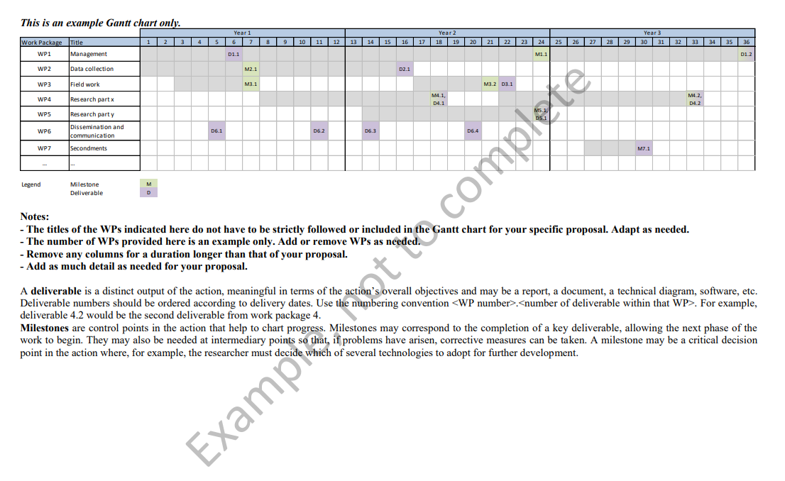
Add or remove WPs as needed. Include a level of detail appropriate to your project.

Literature or other references should be listed in footnotes, font size 8 or 9. All literature references will count towards the page limit.
A deliverable is a distinct output, meaningful in terms of the overall objectives and may be a report, a document, a technical diagram, a software, etc. Should the applicant wish to participate in the pilot on Open Research Data, the Data Management Plan should be indicated here. Deliverable numbers ordered according to delivery dates.
Milestones are control points in the action that help to chart progress. Milestones may correspond to the completion of a key deliverable, allowing the next phase of the work to begin. They may also be needed at intermediary points so that, if problems have arisen, corrective measures can be taken. A milestone may be a critical decision point in the action where, for example, the researcher must decide which of several technologies to adopt for further development
https://ec.europa.eu/research/participants/data/ref/h2020/other/gm/h2020-guide-comm_en.pdf
https://ec.europa.eu/research/participants/docs/h2020-funding-guide/grants/grant-management/communication_en.htm
https://ec.europa.eu/research/participants/docs/h2020-funding-guide/grants/grant-management/dissemination-of-results_en.htm

